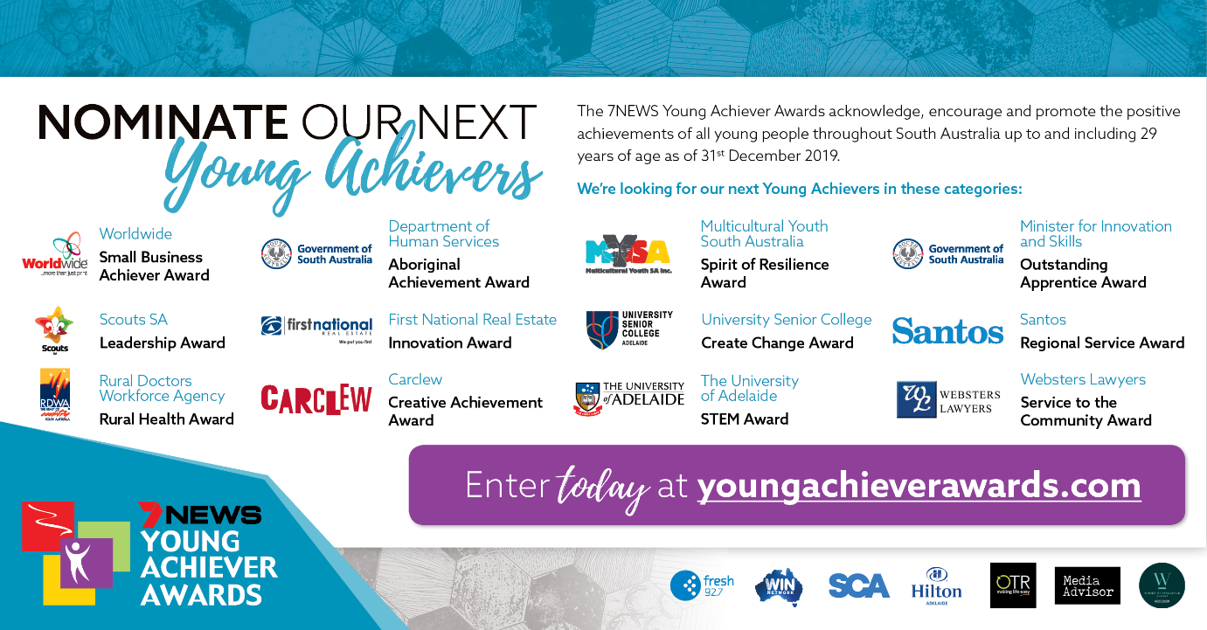
Here are some reasons why we would love for you to enter someone into the Awards:
- It is free to enter
- Winners will be taking home a $2,000 Award Prize thanks to Awards Australia and will also receive a magnificent trophy
- A media release is sent out for every nominee that enters, in turn increasing promotion for the nominee
- Should the nominee become a semi-finalist or a finalist, we will promote them on our social media pages and further media releases will be sent to their local papers
- Everyone who is entered in the Awards receives a certificate of achievement
The 7NEWS Young Achiever Awards South Australia aim to acknowledge, encourage and most importantly promote the positive achievements of all young people up to and including 29 years of age.
Below is a list of categories that are now open. Ready to answer the questions? Go to our online portal and select the category from the dropdown nomination award menu.
To find out more about the Awards pleases see our website.

