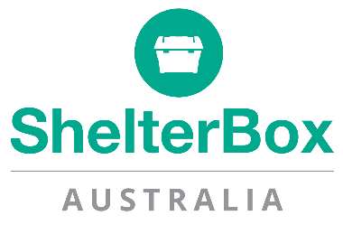

As you know we have been closely monitoring the situation in Tonga ever since news of the volcano and tsunami emerged. After much investigation and consultation, it has recently been announced that ShelterBox will not be responding in Tonga.

We will continue to focus on going where people will not receive shelter support from any other sources after disaster and where there is a clear need for ShelterBox. Our reasoning is based on the findings below.

- In Tonga, large-scale government responses are being provided by New Zealand, Australia, China, with further support from Japan and the UK.
- People in Tonga are also receiving support from other organisations with local or regional presence including the Red Cross, UNICEF and ERKs (Rotary New Zealand’s Emergency Response Kits for the Pacific area).
- We have been working with these organisations and others to understand the likely extent of shelter aid need and we believe communities in Tonga are likely to receive support from those organisations.
- The Red Cross has aid in Tonga which it has started to distribute. UNICEF has supplies in Brisbane and Fiji, which are also being sent to Tonga.
- ShelterBox is helping people across the world who have had to leave their homes because of disaster or conflict. We are currently working in the Philippines, following the super typhoon that hit the country last month, as well as in Syria, Cameroon, Ethiopia, Nigeria, Yemen, Burkina Faso, Mozambique, and Haiti. ·
- ShelterBox teams have responded with emergency shelter in the South Pacific region before, most recently in Vanuatu and Fiji.

For the above reasons, we have not launched an appeal for Tonga and continue to concentrate on our Typhoon Rai Appeal, to help those affected by the super-typhoon that hit the Philippines just before Christmas.

Mike Greenslade
Chief Executive Officer
Shelterbox Australia

